**Three Conclusions about Kickstarter campaigns**

1. From the data of Kickstarter campaigns, we observe most of the projects were launched in the United State of America (74%). A major chunk of Kickstarter projects are theaters (34%), music (17%) and technology (15%). Among all projects, about **53% succeed**, and **37% fail.** It is intuitive that success rate varies across different categories due to the unique nature of each category. The most successful are music (77%), theater (60%) and film & video (58%).

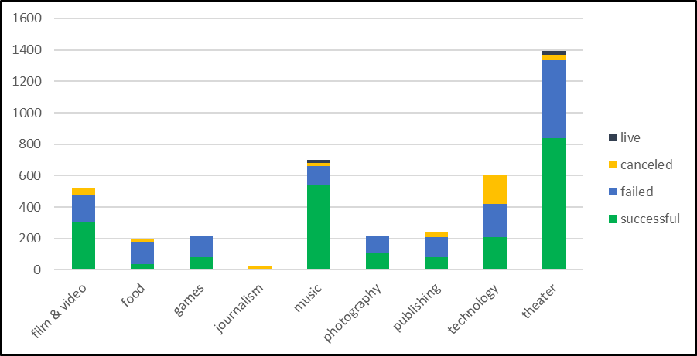

1. If we study success rate and failure rate against subcategory again it’s varied widely. For example, the successful category is music but if we study its subcategory highest count of projects with highest success rate is rock. Though some other subcategory of music has 100% success rate but no of project is less.

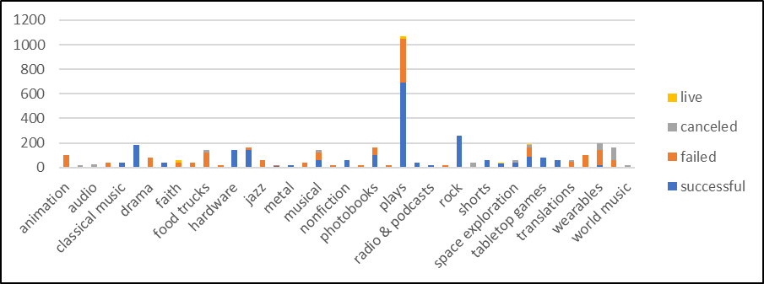

1. After May month there is decrease in the success and the gap between success and failed narrows down and intersect each other in Dec month. If we see canceled there is no major change in it and its almost the same throughout the year. Even if we checked each category individually, no category shows successful trend in December month.

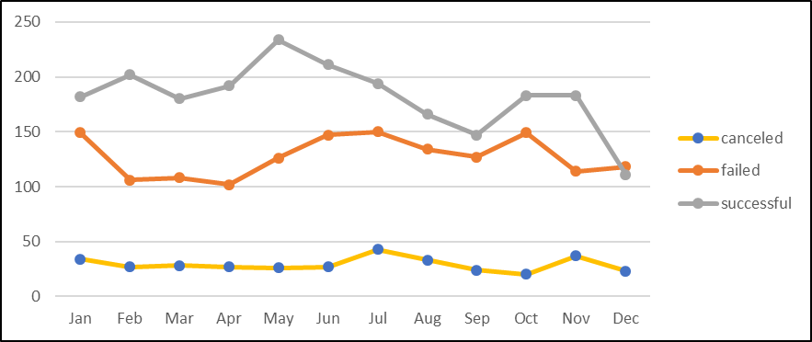

**Limitations of the Dataset**

* The number of projects is not same for all categories and subcategories, for some of them it’s too small. The small project size may not be representative of the true picture. We need to find out how statistically significant these results are.
* We need to analyze more crowdsourcing companies for significant results.

**Other analyzations we could perform**

* We could analyze the projects state wise by the time duration taken to complete the project using the date created conversion and date ended conversion.
* We could analyze the graph of pledged amount with parent category to see which categories are highly funded and which are poorly funded.